Log From Chile, Jan. 5-23, 2002

The trip lasted 3 weeks. The first week was with Oscar Santiago-from the GMU MBA program and myself; the second week was with Oscar, myself, Glenn Harshmann-from the GMU MBA program, and Blake Cambey-friend of Oscar’s from undergrad in NYC, and the third week was with Oscar, Blake, and myself…Glenn flew back to Santiago for an Espagnol immersion program. Disclaimer: Oscar recently got engaged to a great girl (I haven’t actually met her, but am sure she is just that), and many names/details have been omitted to protect the innocent and the guilty)… we were trying to convince Oscar this was his preliminary bachelor party…it was a good excuse to party a little. Below is the map we bought from a Copec station (the most prevalent gas station in Chile, and the one with the best service and free bathrooms. The dated notes are below the maps.

Map of Chile  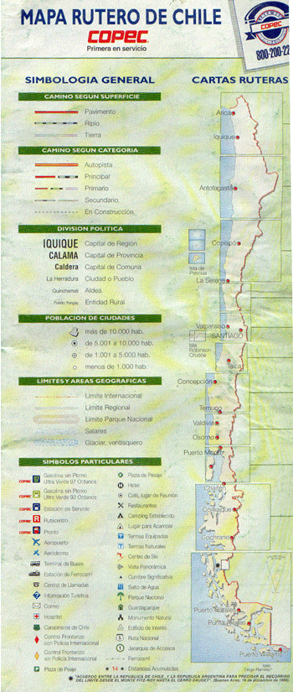  Mileage  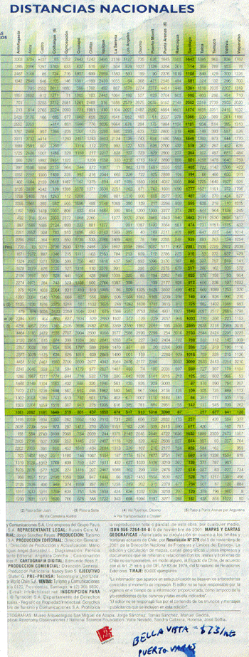 | Driving Route  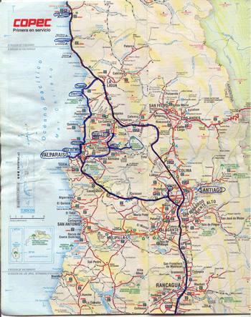  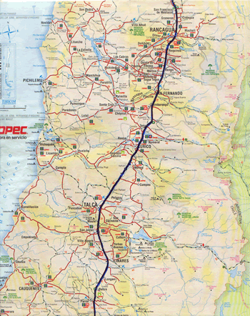  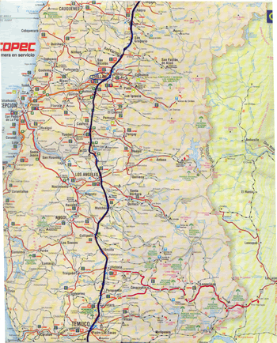  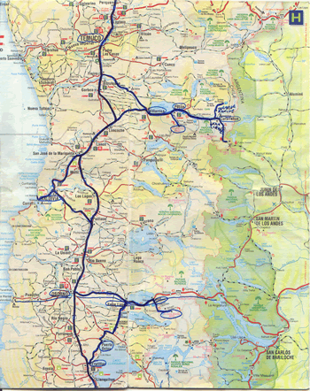  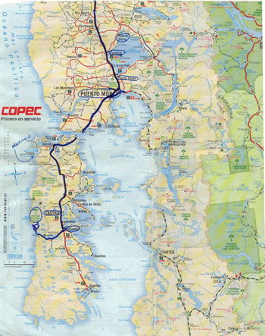

1/6/2002 (Sun.): Flew into Santiago, Chile and rented red Nissan 4-seater pickup truck from a no-name rental company for $640 for 3 weeks. Drove to house in Valparaiso being renovated that has a great view of the city. The family is really nice (1 young boy, 1 young girl, 1 teenage girl). The wife (Martina) is from Germany and husband (Enzo) from Chile. We met a young married couple from Denmark who rented the loft (top floor with an excellent view of the city). Walked around Valparaiso; an open-street party was going on in the center of town. [House address: Enzo & Martina, Avenida Quebrada Veroe 192, Playa Ancha-Valparaiso, Phone: 032-288873; email: villakunterbuntvalpo@yahoo.de; buses 1-4 go by the house; nice old 3 story house being remodeled; hosts are apt to offer beer on the open-air (covered by a colorful tarp) patio.

1/7/20002: Went with 2 Danes who stayed at Enzo and Martina’s and spent the day with them. Walked around Valparaiso and took lift and buses. Buses are cheap (US$.50) and run everywhere in and around the city. Drove to Parque Nacional La Campana and hiked up a mountain (Co La Campana), where Darwin climbed and conducted studies of wildlife. Hiked ½ way to top, turned around and drove to Quillota to look for hats we saw on Chilean horsemen (cowboys). After 2 hours, Oscar and I had custom-made hats (chapallas). We drove back to Valparaiso via Vina del Mar, which is much nicer and more modern than Valparaiso. Vina del Mar reminded me of Cannes, France. Valparaiso is a shipping port and has no good beaches. The town is hilly and most residents speak only Spanish. Foods discovered were: Hote con Huesillo (a sweet drink with dried peaches and puffed wheat), Pastel de Choclo (a corn/meat mixture in a bowl; you can ask for without sugar), and Humitas (a corn/meat mixture wrapped in corn stalks)…you don’t eat the corn stalks.

1/8/2002: Drove north through Renaca, which has a nice beach with lots of women and tourists. Ate lunch at a good restaurant (Perla del Pacifico) on north side of Concon. For lunch, had Ceviche (strips of fish cooked in onions and lemons). Fish was corvina (sea bass). Also had empanadas with crab. Abalone (called loco) was delicious and had a great texture and taste. Oysters are called ostra; scallops are called osteon. Picked up 2 girls (probably 14 or so) and took them to the beach (they were walking on the roadside). Beach just south of Zapallar was nice and crowded. Oscar and I swam a little in the chilly water and relaxed as Oscar spoke a little Spanish with the girls. I relaxed and spoke a little English to myself and tried to keep up with the conversation in Spanish (unsuccessfully for the most part). Zapallar itself is a riche area, similar to Carmel, California. It has a lot of expensive houses but few hotels. Costs are expensive for Chle, similar to those in the U.S. Stopped by Isla Seca (hotel north of Zapallar); cost was US$140 per night for a room with a great view and pool, and nice restaurant. We decided to drive further north in search of lower prices. Stopped for the night in Papudo, which is a great little town with a nice beach. Oscar and I went to a discotheque (Jungle Help) right off the beach. It opened at 0000 (midnight) but didn’t really get going until 0200. The average age was probably around 16. I am surprised at the small percentage of people who speak English. I’m slowly picking up the basics in Spanish (ena cerveza, por favor; pisco sour, etc.)…and mixing them up with my French. Papudo seems like a nice, relaxed town. We ate at the Banana restaurant, just off the beach and stayed at a place for US$9 each. We shared a room with a sink. The bathroom is shared with all rooms. The Chilean diet (from restaurants) is lacking in fruit and veggies. We plan to buy some fruit and veggies today and have a salad. I bought some drugs from a pharmacy today for my cold, but still haven’t kicked it yet. [I would end up getting over the cold that I had caught while returning from Savannah, GA to Washington, DC, prior to the flight to Chile, but had an enduring cough that I am just beginning to get over.] We tried a Pisco Sour (Chile’s national drink is pisco, and the town where it was invented was renamed in its honor.)

1/9/2002 (Wed.): Drove north from Papudo to Pichidangui, which has a great 7km long beach. Looks like a great area to stay for a day. Continued driving north to Los Vilos where we ate lunch at a restaurant on the beach. Great food. Had albacore (loco) appetizer and conger eel with potatoes (congrio ingles con papas naturales). Los Vilos is a small town with a nice beach (almost as nice as Pichidangui, but not quite as relaxing). Oscar and I decided to stay in Los Vilas after meeting a great family who we rented a cabana from. The cabana had a great view of the beach and ocean, and binoculars were leant to us by the owners. We paid 10,000 pesos each (US$15 each) for the place. We went to 2 discotheques last night. Oscar and I decided to spend atleast 1 more night here and relax a little. [After visiting a few nightclubs, the music grew on us, and we started to enjoy the music/dancing. The locals have their own dance moves that everyone does together on certain songs.] The family who owns the beach house invited us in for drinks (pisco and a Coke) and gave us a snack for dinner. Mother’s nickname is Pollyta (little chicken), son who is in Chilean Army is Paul. He trained recently at Ft. Benning, GA. Paul’s girlfriend is Caroline.

1/10/2002: Pollyta invited us to a big lunch at 1400. Oscar and I bought the ingredients and she will prepare a fish stew. Oscar and I stayed out until around 0600 last night. Beach by day, out by night. Lunch was prepared by Pollyta and her family. They made a great low country boil with mussels, clams and chicken. It was the best meal I’ve had in a while. I took pictures, of course. At night, Oscar and I went out. There was a power outage for an hour or so in the town.

1/11/2002: Pollyta prepared another great lunch, and we hit the beach again. I fixed spaghetti for dinner (Chileans are not big on pasta.)

1/12/2002: We drove to Santiago and met up with the others from the GMU MBA 798 class Oscar and I had originally signed up for. We spent the night in the Eurotel Hotel for US$57 per night (with the GMU discount). We stayed in separate rooms and relaxed for the night.

1/13/2002 (Sun.): Drove south with Oscar, Glenn, and Blake. Stopped in Chillan for dinner. Almost everything was closed on Sunday and restaurant choices were limited to two. Spent the night in Temuco.

1/14/2002: Went to open market in Temuco and bought souvenirs (refrigerator magnets, wool sweater, toys, knit cap, jewelry made of lapiz-lazuli (a bluish stone). Prices were reasonable and negotiable. Drove south through Villarrica and Pucon. Pucon is a tourist town and prices reflect it. Spent the night at guest house Kila-Leufu, a working Mapuchi (indigenous Indians) farm. Pucon has a large lake and many hot springs (termas) in the area, most unmarked on maps. Made reservations to climb a volcano (Volcan Villarrica, 2,847m.) on Tuesday with Aguaventura guides. They provided all equipment (crampons, ice axe, outer pants, wind breaker, boots, sunglasses, ball cap) if you need it. Cost: 20,000 pesos (US$35).

1/15/2002 (Tues.): I was glad we had the climbing guide to lead us up the mountain along the paths they knew/made through the snow. The first part of the climb was over hard rock. We had to hike from the bottom up a gravel trail along the ski lift path; because of high winds, the ski lifts weren’t operating. The second part of the climb was through snow using ice axes. This was a first for me. To use the ice axe, a climber should place the hand on top with fingers around the blade, keeping the axe on the uphill side. In case you fall, keep one hand on top of the axe and place the other hand on the handle, then push the blade of the axe into the snow to stop your fall. Never put both hands on the handle, as you may lose your grip and continue to fall after the axe gets stuck in the snow. We cut back and forth through the snow until reaching an area close to the top with hard rocks. We didn’t need crampons because of the warm weather (snow was not icy on the face). Glenn turned back before the first rest stop because of an injury to his ankle he suffered earlier that morning. We took 3 rest breaks on the way up. At the very top there was snow (black) and rocks. Smoke continuously comes out and at night you can see a reddish glow reflected from the volcano off the smoke. There is a magnificent view from the top of the volcano, and one person told me you can see over 250 km. We started the climb at 0830 (met at Aguaventura at 0730); up took approximately 5 hours, down took 1 hour, 15 minutes. To get down, we slid down on our butts through paths in the snow (like a bobsled run), and ran down the gravel part toward the bottom. This was the steepest climb and first snow climb I’ve ever done. We were all tired afterward, and enjoyed the beer provided by Aguaventura. I saw several people on other tours who turned back before making it to the top. Out of 10 people in our group, 9 made it to the top. It was a blast, well worth the cost. It reminded me of how long it’s been since I’ve participated in a concentrated workout regimen, especially aerobic activity. I was out of breath toward the top and had a leg cramp from halfway up to about ¾ of the way up the mountain. But, of course, I had to get to the top. We spent the night at Kila-Leufu, just east of Pucon again. Total cost per night was 15,000 pesos. After having a great dinner of vegetable soup for the main course, we all headed out to the large hut in the back where a fire was blazing and talked with the other guests for about one hour.

1/16/2002 (Wed.): Drove south to Valdivia. We never went and relaxed in the hot springs (termas). It is supposed to be best for termas in the early morning or late evening, when it’s not so hot outside. We got out first flat tire and dad it fixed at a vulcanization shop (auto repair) in Curarrehue. The patch didn’t hold and we ended up having another put on in Valdivia. We had planned to cross the border into Argentina at Paso Mamuil Malal (east of Curarrehue). After stamping our passports on the Chilean side, we were told we couldn’t drive the car over without an original signed document from the rental company authorizing us to drive the truck into Argentina. So, instead of driving south in Argentina and coming back into Chile along I215 into Osorno, we drove back to the Pan American Highway (Ruta 5) and headed south into Valdivia. We stayed at a great hostelaria (Hostelaria International) for 5,000 pesos per night each, where the bars and dance clubs were located just around the corner. We ended up going to Club Cubano and had a blast. Night life starts happening at around 0030 or 0100. We all mixed with the locals and danced a little to salsa and meringue, etc. There was a very attractive girl dancing with 2 girl friends and some guys at Club Cubana both nights we went. I told her as she was leaving the second night that she was a great dancer (in Espagnol, of course…my language skills slowly improved). I enjoyed just sitting and watching her dance she was so good. She was the best dancer I’ve seen who wasn’t on the TV in a professional ballroom dance contest. Surprisingly, she grabbed my hand and came in close and started talking, saying she wished I had danced with her. She was extremely nice, and from Chile (I guessed she was from Argentina initially). I explained that I was nowhere near her level in the salsa, and she and her friends departed for the evening.

1/18/2002: We drove south to the lake district, through Frutillar and spent the night in Puerto Varas definitely tourist areas. The prices are higher (we paid 7,000 pesos per person for a night at a hostelaria) and the weather has changed dramatically. We saw our first Chilean storm clouds in Frutillar and it is sprinkling in Puerto Varas. The temperature has dropped 10-20 degrees Fahrenheit, compared to the central region. I slept 13 hours last night and think I have finally kicked my cold. The others (Glenn, Oscar, and Blake) all went into town and saw the casino.

1/19/2002: (Sat.): Today we will drop Glenn off at the Puerto Montt airport (which was very small) for his flight back to Santiago, and after debating, the remaining 3 of us have decided to drive southward to the ferry to Chiloe. On Chiloe, Castro is a medium-sized town, with no beaches to speak of, used mostly for shipping. The ferry ride to Chiloe was great. Ferries leave every 30 minutes and we drove righ onto one that left within 5 minutes of our arrival. We met 2 really nice girls who spoke English (Marianna Loreto) and their father. The ferry ride took about 30 minutes. We drove to Chonchi and decided to spend the night and eat in the cabana (at 6,000 pesos per person per night= 18,000 pesos total). We gave 3 girls a ride into town who backpacked around Chile and are from Argentina (Buenos Aires). Chonchi is a really small town with few restaurants, no real beach, and no night life to speak of. So far, if I return to Chile, judging by what we’ve seen, I would probably fly into Puerto Montt, stay in Puerto Varas and Frutillar and around Lago Llanquihue and relax in town. Glenn said there were no real night clubs, but there was jass playing around the square (Dave Brubeck) and Puerto Varas also had a nice little casino.

1/20/2002: After talking to the 3 Argentinians more, we decided to drive along with them to the western side of the island. After dropping them off so they could wait for their 3 other friends who were hiking, Oscar, Blake and I hiked around the national park at Punta Saliente and ate lunch (fish we bought in Cucao) on the beach. A seal was sunbathing and the beach was beautiful, having a haze of water drift over from the waves in the ocean. There were many shells on the beach. After a siesta on the beach, we drove back up the long dirt road to the Pan American Highway nad caught a ferry back to Pargua. In the lake district and especially in the national park on Chiloe, there are huge horseflies that buzz around slowly, following hikers. Oscar had the misfortune of being bitten by one. We made it to within 50 miles of the southern end of the Pan American Highway. We spent the night at a place in Puerto Octay called Zaputo Amarillo (the yellow shoe). The place is outside town and is really beauriful (a great place to relax off the beaten path). There is a little guide called (Backpacker’s Guide) that includes a lot of the places we stayed in Chile. The first one listed is “Scott’s Place” in Santiago, Chile. Many backpackers picked up the guide from there and phoned ahead to various places where they intended to stay. Who needs hotel rooms when hostelarias and cabanas are cheaper and more fun to stay at? On Chiloe, we barely missed seeing penguins. We didn’t find out where they were until the ferry ride back. They are in an area on the northwestern part of the island, west of Ancud (Pinguinera Islotes de Punihuil). We thought they’d be further south.

1/21/02 (Mon.): We decided to climb Volcan Casa Blanca. We drove to the base and started the climb at 1600. It took us 2 hours up and 1.5 hours to get down. We stayed at the top for 1 hour and signed the guest book there. We made it back to the truck just before nightfall at 2100 and stayed at a cabana on highway 215 for 18,000 pesos/night.

1/22/2002: We drove back east on highway 215 to Termas puyehue (a resort hotel with hot springs). The hotel is beautiful (similar to the Broadmoor in Colorado) but pricey at US$120/night. All day outside termas and a 50 minute massage was 20,000 pesos. After relaxing in the termas until around 4 pm, we began the long drive back to Santiago, heading north on Ruta 5. We made it to Los Angeles by around 23:10, where we got a hotel room just off the road for the night for 24,000 pesos (the most we paid for a room the entire trip).

1/23/2002 (Wed.): Woke up early (left the room at 0800) and finished driving to Santiago. Oscar and Blake have found a room near the center of town and Oscar is planning to drop me at the airport for my flight out ant the same time he drops the rental car off.

Overall, the southern part (lake district) is more humid than the north of Chile. The northern coast is nice, but for relaxing, Puerto Varas is a great spot. Valdivia is a great place to party and meet people, and Santiago offers the city life. In the smaller towns, it is a requirement to speak Spanish. In Santiago, you may be able to get by without speaking Spanish.

If I return to Chile, I’d like to do what the Danish couple we met were planning…fly into Puerto Montt, take a bus to Quellon on Chiloe Island, then take a 3 day ferry from Quellon to Pto Chacabuco to the south in Tierra del Fuego. Spend some time down there observing ice bergs and penguins, and from there fly back to Santiago.

